## US Permanent Visa Case Study

Chandramouli Yalamanchili

Case Study: Perform analysis to identify different important factors that could impact the US permanent visa application. Also build a model to predict the approval of the US permanent visa application.

I have used the US permanent visa dataset and run various graph analysis on the selected features to see how each of them impact the outcome of the US permanent visa application.

Goal:

* To understand how different variables/features impact the decision of the US permanent visa applications using different types of graph analysis techniques.

Dataset:

* Original dataset has been taken from <https://www.kaggle.com/jboysen/us-perm-visas>.
* In previous classes, I have applied several data preparation techniques on this dataset by combining few columns and by normalizing the data in few columns.
* For this exercise I have used the the final CSV file created out of my previous exercises.
* The input file used is attached with this post – *us_perm_visas_final.csv.*

**Features used:**

Below are the features I have extracted and used from the dataset.

* case_status - This is the status of the US Permanent visa application.
* entry_visa – Type of visa that the candidate entered into USA with.
* citizenship - Country of citizenship of the candidate.
* no_of_employees - Number of employees under the employer who filed petition for the candidate.
* state - USA state where employer is located.
* job_level - Level of the job role, or expertise level of the candidate.
* year - Year of the application decision.
* salary - Salary offered to the candidate for the position.

Below are some of the other variables present in the input dataset that I dropped for this case study as I didn't see them fit.

* employer_name
* job_info_work_city
* pw_job_title_9089
* pw_soc_title
* birth_country

The step-by-step instructions to perform the graph analysis:

1. Load the data from the 'us_perm_visas_final.csv' into pandas data frame. Displayed the initial dataframe structure as part of this step to understand the data I have currently in the dataframe. I didn’t drop rows with missing values yet. These are the details of raw dataset.

The dimension of the table is: (374362, 17)

Top 5 rows case_number case_status class_of_admission country_of_citizenship \

0 A-07323-97014 Certified J-1 ARMENIA

1 A-07332-99439 Denied B-2 POLAND

2 A-07333-99643 Certified H-1B INDIA

3 A-07339-01930 Certified B-2 SOUTH KOREA

4 A-07345-03565 Certified L-1 CANADA

decision_date employer_name employer_num_employees \

0 2012-02-01 NETSOFT USA INC. NaN

1 2011-12-21 PINNACLE ENVIRONEMNTAL CORP NaN

2 2011-12-01 SCHNABEL ENGINEERING, INC. NaN

3 2011-12-01 EBENEZER MISSION CHURCH NaN

4 2012-01-26 ALBANY INTERNATIONAL CORP. NaN

employer_name.1 employer_state \

0 NETSOFT USA INC. NY

1 PINNACLE ENVIRONEMNTAL CORP NY

2 SCHNABEL ENGINEERING, INC. VA

3 EBENEZER MISSION CHURCH NY

4 ALBANY INTERNATIONAL CORP. NY

foreign_worker_info_birth_country job_info_work_city job_info_work_state \

0 NaN New York NY

1 NaN New York NY

2 NaN Lutherville MD

3 NaN Flushing NY

4 NaN Albany NY

pw_job_title_9089 pw_level_9089 \

0 Computer Software Engineers, Applications Level II

1 ASBESTOS HANDLER Level I

2 Civil Engineer Level I

3 File Clerk Level II

4 Sales & Service Engineer Level IV

pw_soc_title pw_amount_9089 \

0 Computer Software Engineers, Applications 75629.0

1 Hazardous Materials Removal Workers 37024.0

2 Civil Engineers 47923.0

3 File Clerks 10.97

4 Sales Engineers 94890.0

pw_unit_of_pay_9089

0 yr

1 yr

2 yr

3 hr

4 yr

Rows with missing data by column:

case_number 0

case_status 0

class_of_admission 22845

country_of_citizenship 59

decision_date 0

employer_name 12

employer_num_employees 135349

employer_name.1 12

employer_state 42

foreign_worker_info_birth_country 135300

job_info_work_city 102

job_info_work_state 103

pw_job_title_9089 392

pw_level_9089 27627

pw_soc_title 2336

pw_amount_9089 2216

pw_unit_of_pay_9089 1572

1. Data clean up and preparation as needed for graph analysis. I have performed below data clean up steps to extract the data in the format needed for graph analysis. Majority of the changes as part of case study part 2 are done as part of this step.

* Dropped the rows that have NA values in the columns - ‘class_of_admission’, 'country_of_citizenship', 'employer_state', and 'pw_unit_of_pay_9089'.
* Selected only few interested columns and dropped the rest of the columns. Also, renamed the column names.
* Field extraction - extracted salary field using two fields, pw_amount_9089 & pw_unit_of_pay_9089, I have extracted the yearly salary for all rows.
* Selected rows from years 2014, 2015 & 2016 years only to reduce the dataset size.
* Transformed job_level data from text into numeric by assigning unique value for each job level.
* At this point I had all of the selected rows, so I have done reset_index to reset the index on the dataframe.
* Below is how dataset looks like after step 2:

Dataset state after step 2 - feature and data selection

The dimension of the table is: (279365, 8)

Top 5 rows case_status entry_visa citizenship no_of_employees state \

0 Certified-Expired H-1B INDIA NaN MASSACHUSETTS

1 Certified-Expired H-1B INDIA NaN ARKANSAS

2 Certified H-1B INDIA NaN NEW YORK

3 Certified-Expired H-1B SOUTH KOREA NaN CALIFORNIA

4 Certified H-1B INDIA NaN WISCONSIN

job_level year salary

0 Level IV 2014-02-21 116542.4

1 Level I 2014-01-08 42973.0

2 Level III 2014-05-22 101629.0

3 Level II 2014-03-28 60445.0

4 Level IV 2014-05-28 92414.0

Rows with missing data by column:

case_status 0

entry_visa 0

citizenship 0

no_of_employees 57167

state 0

job_level 19805

year 0

salary 0

dtype: int64

1. Modify the feature values on selected rows - in this step I have modified the extracted feature values either to normalize them, or to fill missing values or to extract more meaningful value.
   * Filling the missing values in the dataset - as you have seen above, after step 2 we still have some missing fields, I have filled those as below:
     1. No_of_employees - used the median to fill the missing values.
     2. Job_level - used the most frequent value to fill the missing values.
   * Value normalization - I have used log normalization to normalize the salary & no_of_employees features to remove the skewed data we have seen last week. Below is the data before and after log normalization:

Top 5 rows after log transformation for salary & no_of_employees along with the original values

salary salary_log no_of_employees no_of_employees_log

0 116542.4 11.666019 1634.0 7.399398

1 42973.0 10.668351 1634.0 7.399398

2 101629.0 11.529094 1634.0 7.399398

3 60445.0 11.009506 1634.0 7.399398

4 92414.0 11.434045 1634.0 7.399398

* + Year - derived the 4 digit year from the date.
  + Below is how the dataset looks after step 3:

Dataset state after step 3 - modifying some features and filling missing values

The dimension of the table is: (279365, 10)

Top 5 rows case_status entry_visa citizenship no_of_employees state \

0 Certified-Expired H-1B INDIA 1634.0 MASSACHUSETTS

1 Certified-Expired H-1B INDIA 1634.0 ARKANSAS

2 Certified H-1B INDIA 1634.0 NEW YORK

3 Certified-Expired H-1B SOUTH KOREA 1634.0 CALIFORNIA

4 Certified H-1B INDIA 1634.0 WISCONSIN

job_level year salary salary_log no_of_employees_log

0 4.0 2014 116542.4 11.666019 7.399398

1 1.0 2014 42973.0 10.668351 7.399398

2 3.0 2014 101629.0 11.529094 7.399398

3 2.0 2014 60445.0 11.009506 7.399398

4 4.0 2014 92414.0 11.434045 7.399398

Rows with missing data by column:

case_status 0

entry_visa 0

citizenship 0

no_of_employees 0

state 0

job_level 0

year 0

salary 0

salary_log 0

no_of_employees_log 0

1. Understand different variable types we have in the dataset, I ran describe and summary commands on the dataset.

Describe Data

no_of_employees job_level year salary \

count 2.793650e+05 279365.000000 279365.000000 279365.000000

mean 1.992288e+04 2.551426 2015.146586 88646.609885

std 5.044350e+05 1.047190 0.811143 31965.935855

min 0.000000e+00 1.000000 2014.000000 10400.000000

25% 1.700000e+02 2.000000 2014.000000 71074.000000

50% 1.634000e+03 2.000000 2015.000000 88254.000000

75% 1.080000e+04 4.000000 2016.000000 106288.000000

max 2.635506e+08 4.000000 2016.000000 885666.000000

salary_log no_of_employees_log

count 279365.000000 279365.000000

mean 11.313593 7.199814

std 0.431814 2.754739

min 9.249657 0.000000

25% 11.171491 5.141664

50% 11.387986 7.399398

75% 11.573917 9.287394

max 13.694096 19.389756

Summarized Data

case_status entry_visa citizenship state

count 279365 279365 279365 279365

unique 4 54 197 112

top Certified H-1B INDIA CA

freq 147213 222234 159643 36454

1. As part of this step, I plotted some histograms to understand the data from different perspectives. Below are some of my observations from the histograms plotted.

* Salary - Due to normalization, the graph looks more distributed now, removing the left skewness I had earlier. I have left the picture from original analysis as well to show the difference. Based on the initial analysis, as can think most of the applications seems to be around $100,000, so I didn’t find any surprising findings here other than a small and interesting spike at $190,000.
* Number of employees - Due to normalization, the graph looks more distributed now, removing the left skewness I had earlier. I have left the picture from original analysis as well to show the difference. Based on the initial analysis, I was definitely not expecting more than 1000 companies having around 50,000 employees so that is an interesting finding.
* Job level - As H1B visa contributes to most of the permanent visa candidates that could be contributing here reflecting that level 4 candidates are more in number.
* Year - this one is pretty straight forward, we had increasing number of cases over last few years, so this is in line with what I was expecting to see.

**Histogram charts including both raw and normalized values for salary & no_of_employees:**

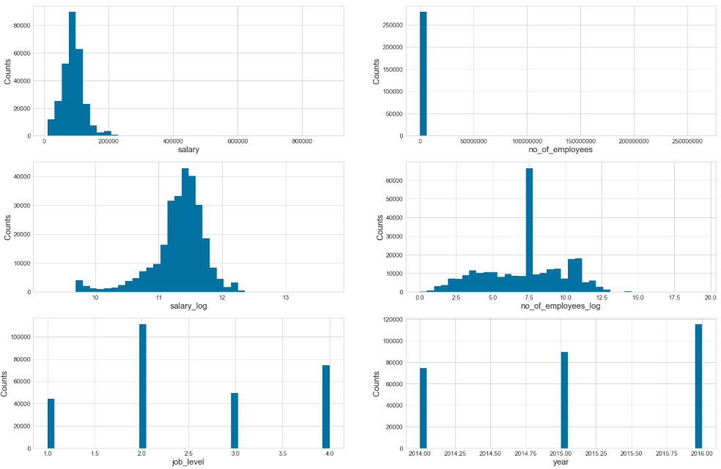

1. I have plotted bar charts using some of the other features, once again to gain understanding of the data from a different perspective. Below are my observations from the bar charts plotted.
   * Case status - I was expecting to see more number of certified or approved cases, which we see in the below chart, but what surprised me was the certified-expired, I was not expecting to see so many of the expired cases.
   * Year - As we have seen before with histogram, bar chart also shows increased number of cases by year.
   * Entry visa type - once again, the chart here meets my expectations and proves my understanding to be correct. Most of the cases are H1B cases.
   * Country - I knew India will be at the top of the list, but wasn’t expecting this much difference with other countries. This is an interesting finding for me.

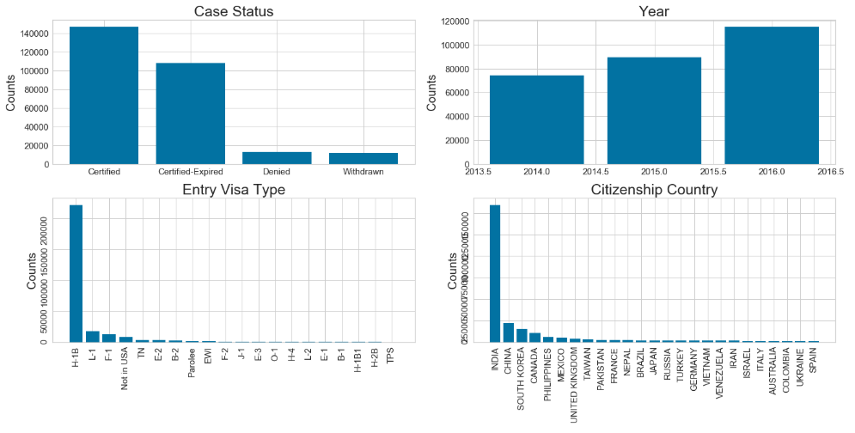

1. As part of this step I have used visualizer to find out the relationship between different features using Pearson ranking. Below are my observations:
   * I see high correlation between salary and no_of_employees.
   * Salary and year are positively related, that’s what we always hope in reality to have increased wages as the year changes.
   * Salary and job level are positively related as well, which would make sense, a person with higher expertise would demand higher salary.
   * All of the remaining parameters are negatively related.
   * But, one of the thing surprised me was not having any strong relations between these fields.

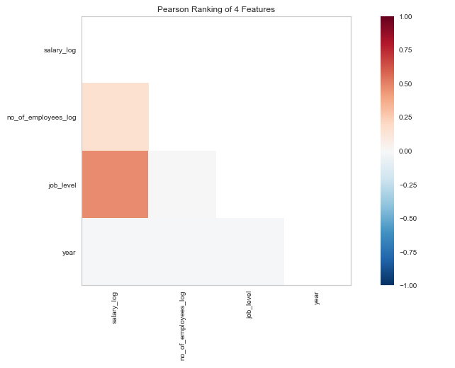

1. As part of this step, I have compared several numeric parameters in the data using the parallel coordinates plot.
   * I did not get any meaningful or clear insights out of the parallel coordinates plot. Only thing we can see is with year, as the year increases we see stronger certified line and in the older years the number of certified-expired cases is high.
   * As part of part 2, I removed the year and arrived at below graph with normalized data for salary and no_of_employees.

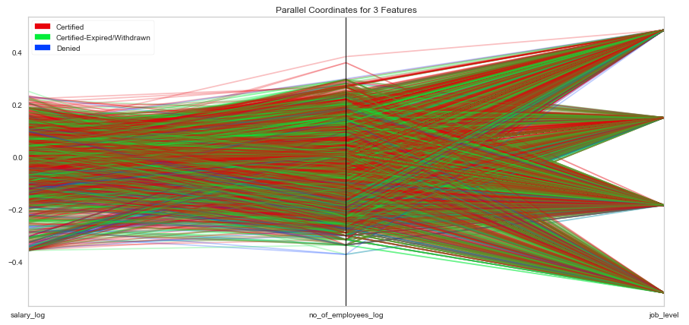

1. As the next step, I have compared various features using the stacked bar chart with respect to case status counts for each feature. Below are my observations out of this step.
   * Year - It is interesting to see we have more approved cases in 2016 compared to 2015, by visual comparison.
   * Job level - One more surprising fact, once again for me is to see those many expired cases.
   * Entry visa - once again we can see H1B leading the chart at a very high margin from other types of visa.
   * Country - India is leading the chart here and seeing a good number of approved cases for all countries.
   * One common thing this chart clearly shows us is that most of the cases are getting approved, seems like very less cases are getting denied.

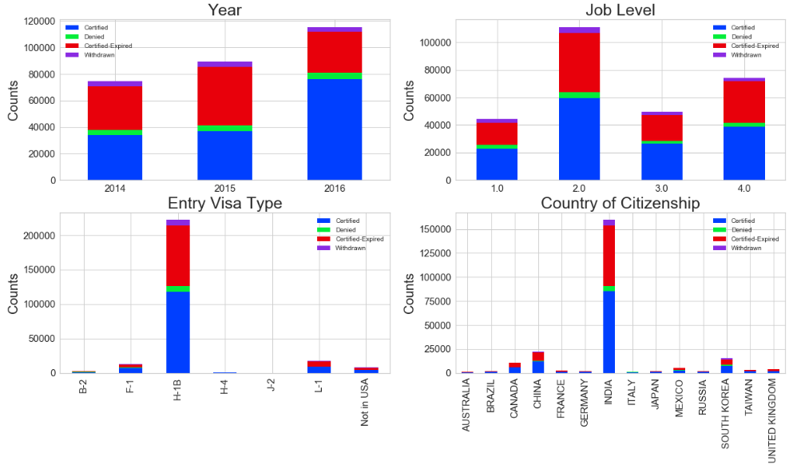

1. As the next step, I have converted few categorical features I have in the dataset to numerical using one hot technique.

Below are the columns that are converted:

entry_visa

citizenship

state

As part of this step, I have also generated data_temp data frame that contains only the rows with either ‘certified’ or ‘denied’ rows. As the primary goal for me is to identify if a particular case would be either certified or denied.

Data before conversion:

entry_visa citizenship state

2 H-1B INDIA NEW YORK

4 H-1B INDIA WISCONSIN

7 H-1B INDIA NEW YORK

23 H-1B INDIA MICHIGAN

24 H-1B INDIA CALIFORNIA

26 E-3 AUSTRALIA NORTH CAROLINA

34 H-1B INDIA GEORGIA

35 H-1B INDIA NEW YORK

Data after conversion:

entry_visa_A-3 entry_visa_A1/A2 entry_visa_B-1 entry_visa_B-2 \

2 0 0 0 0

4 0 0 0 0

7 0 0 0 0

23 0 0 0 0

24 0 0 0 0

26 0 0 0 0

34 0 0 0 0

35 0 0 0 0

entry_visa_C-1 entry_visa_C-3 entry_visa_D-1 entry_visa_E-1 \

2 0 0 0 0

4 0 0 0 0

7 0 0 0 0

23 0 0 0 0

24 0 0 0 0

26 0 0 0 0

34 0 0 0 0

35 0 0 0 0

entry_visa_E-2 entry_visa_E-3 ... state_VIRGINIA state_VT state_WA \

2 0 0 ... 0 0 0

4 0 0 ... 0 0 0

7 0 0 ... 0 0 0

23 0 0 ... 0 0 0

24 0 0 ... 0 0 0

26 0 1 ... 0 0 0

34 0 0 ... 0 0 0

35 0 0 ... 0 0 0

state_WASHINGTON state_WEST VIRGINIA state_WI state_WISCONSIN \

2 0 0 0 0

4 0 0 0 1

7 0 0 0 0

23 0 0 0 0

24 0 0 0 0

26 0 0 0 0

34 0 0 0 0

35 0 0 0 0

state_WV state_WY state_WYOMING

2 0 0 0

4 0 0 0

7 0 0 0

23 0 0 0

24 0 0 0

26 0 0 0

34 0 0 0

35 0 0 0

[8 rows x 348 columns]

1. Create final feature datasets that can be used for train and validation.

As part of this step I have combined the categorical variables converted to numbers with other features I have and generated the X and Y data frames needed for logistic regression model.

I have also separated data frame into two sets, one for training the model and the other for testing the model.

Below are the details from training and testing sets:

No. of samples in training set: 112060

No. of samples in validation set: 48026

Look at different case_status values in the training set:

Certified 103010

Denied 9050

Name: case_status, dtype: int64

Look at different case_status values in the validation set:

Certified 44203

Denied 3823

Name: case_status, dtype: int64

1. Create the logistic regression - as part of this step, I have created logistic regression model and ran several evaluations on the model to see how the model is performing.

**Confusion Matrix:**

* As you can see below, TP (True Positives) are high, but model failed to identify the denied cases accurately, only 99 cases (out of total 3823) denied cases were correctly predicted.

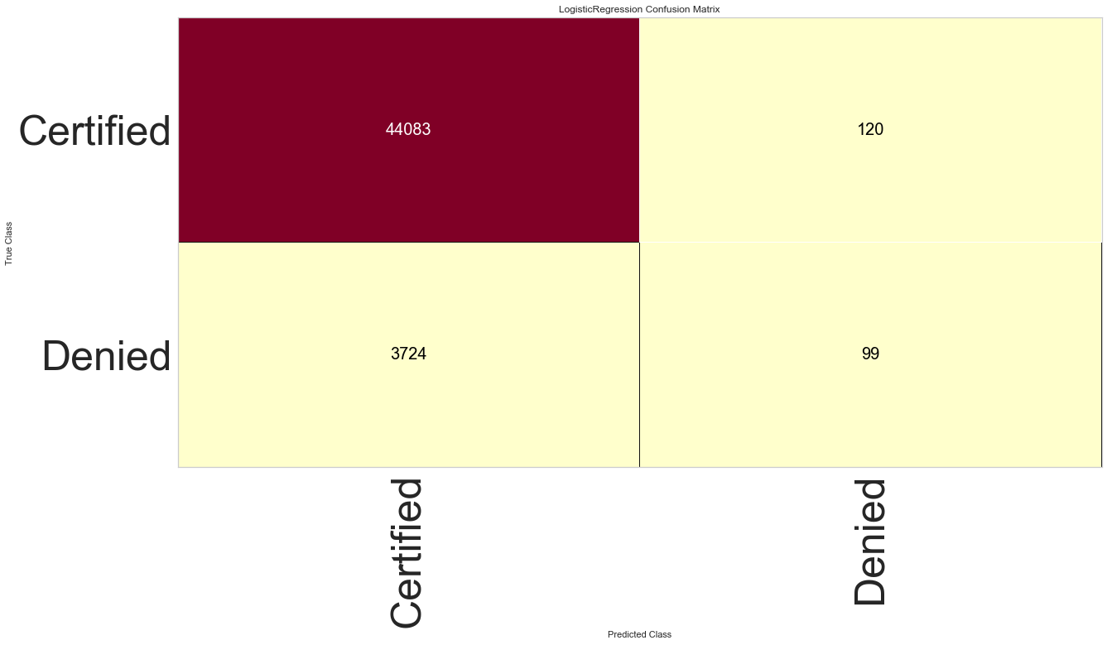

**Logistic Regression Classification Report:**

* Similar to what we have seen in confusion matrix, the other evaluation parameters show the poor performance of the model when it comes to denied class, as shown below.

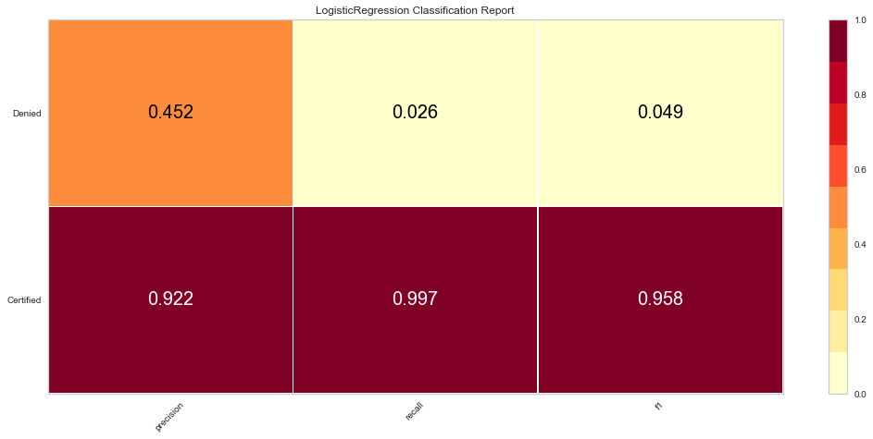

**ROC curves for Logistic Regression:**

* ROC curves show a better performance of the model as all of the curves are above the dotted line, which is randomly guessed.

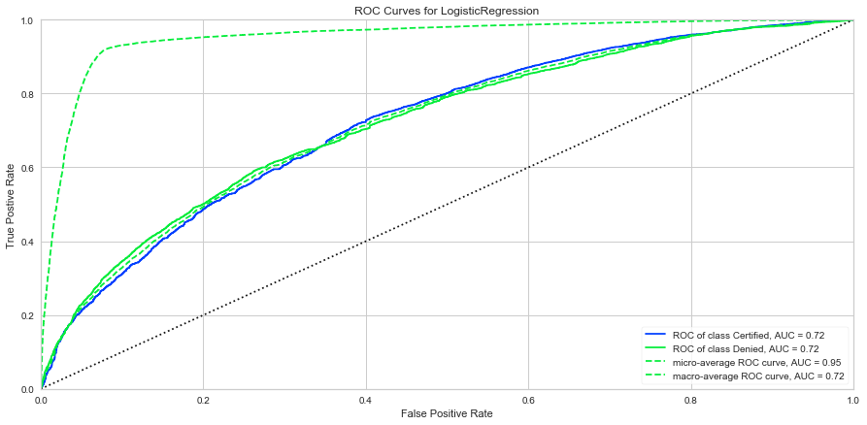

**Conclusion:**

The graph analysis on the US permanent visa applications dataset has given me very good insight into the dataset, helped me in understanding this dataset in different perspective. It also helped me to realize some interesting facts. One of such fact being the very high number of approved, but expired cases. Also one good thing I see out of this analysis is that there are very less number of denials.

As part of part 2 of case study, I learned couple of lessons that it is better to apply the normalization after we complete the graph analysis to understand the data and before we feed data into any models. I have also noticed that conversion of categorical features into numeric through one hot technique is probably not ideal when we have many possible values like in my case. So, depending on how I use this data as part of case study part 3, I will probably have to adopt a different technique.

As part of part 3 of case study, I have built a logistic regression model to predict if a US permanent visa will be granted based on provided data or not. Overall the model I have built seems to be predicting the certified cases well, but predicting too many of the denied cases as certified as well.